3.WATER JUG PROBLEM

Aim
To solve the Water Jug Problem using Python by obtaining the required amount of water using two jugs of different capacities.

Objective
- To understand the Water Jug Problem.
- To find the required amount of water using two jugs.
- To apply a sequence of valid operations such as fill, empty, and pour.
- To display the steps taken to reach the goal state.

Algorithm
- Start.
- Take two jugs with capacities 4 liters and 3 liters.
- Initially, both jugs are empty.
- Fill the 3-liter jug.
- Pour water from the 3-liter jug into the 4-liter jug.
- Fill the 3-liter jug again.
- Pour water into the 4-liter jug until it becomes full.
- Empty the 4-liter jug.
- Transfer the remaining water from the 3-liter jug to the 4-liter jug.
- Fill the 3-liter jug again.
- Pour water into the 4-liter jug until the goal amount (2 liters) remains in the 3-liter jug.
- Display the sequence of states.
- Stop.

Flowchart
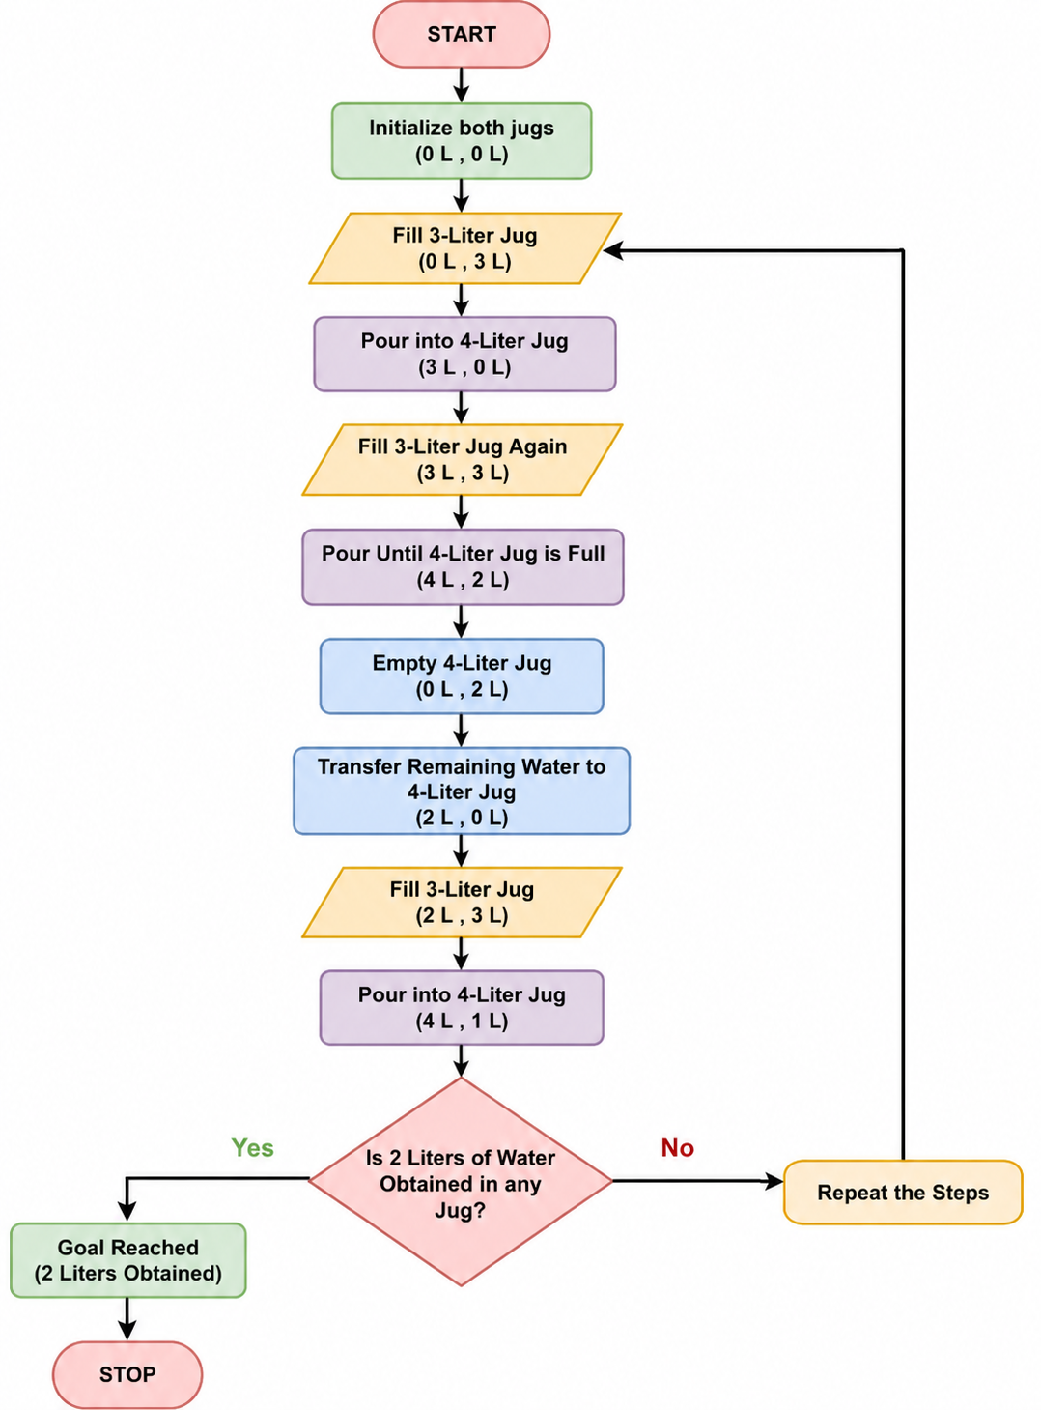

Code
j1 = 4
j2 = 3
target = 2

a = 0
b = 0

print("Initial State")
print("Jug1 =", a, "Jug2 =", b)

while a != target:

if a == 0:
a = j1

elif b == j2:
b = 0

else:
t = min(a, j2 - b)
a = a - t
b = b + t

print("Jug1 =", a, "Jug2 =", b)

print("Target Reached!")

output
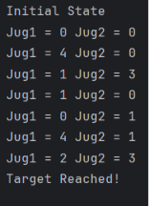
Result
The Water Jug Problem was successfully implemented in Python. The required 2 liters of water was obtained by performing a sequence of fill, pour, and empty operations, and the goal state was reached successfully.

